**SUM OF N NATURAL NUMBERS**

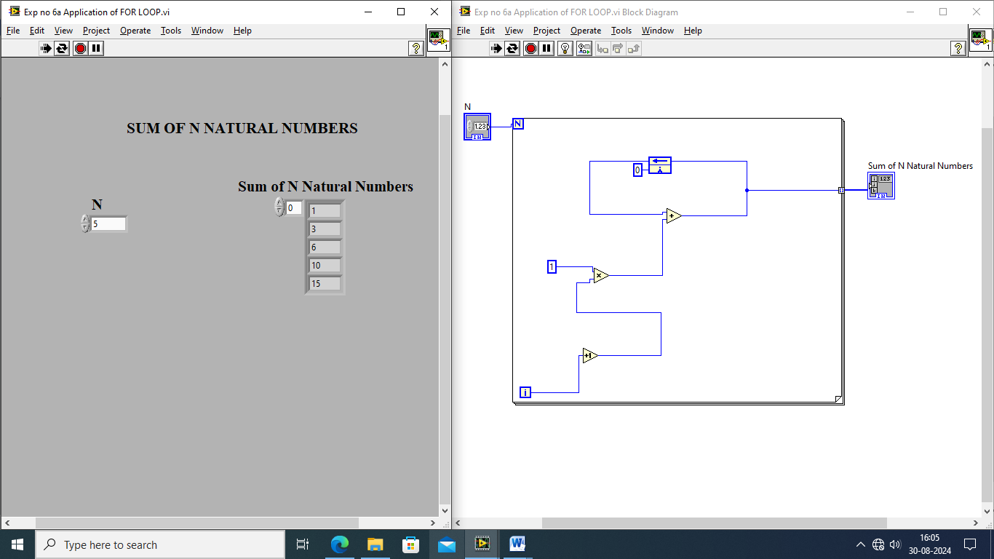

**SUM OF N2 NUMBERS**

